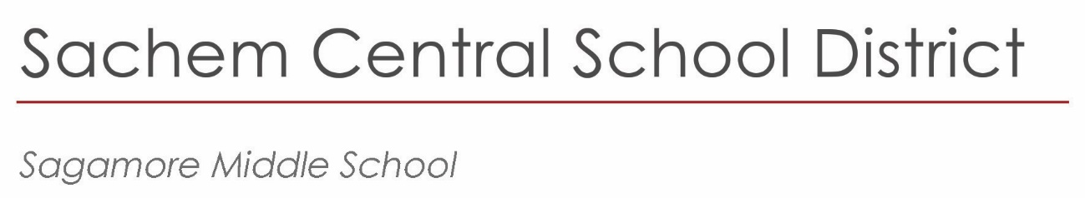

April 2023

**Academic/Community Service Awards Ceremony**

**-Community Service Recognition**

Sagamore Community,

We would like to recognize students who are committed to improving our community and providing support to those in need. Students who have met the criteria outlined below, and submit their application by the deadline of Friday, May 19, will be recognized at our grade level Academic/Community Service Award ceremonies.

**Criteria**

* Students will have to have completed 30 or more hours of community service after July 1, 2022.
* Each activity should have a signature of the adult who oversaw the community service activity. This adult should not be a parent or relative of the student. The person signing must provide a description of their connection to the activity.
* Contact Dr. Galligan if there are extenuating circumstances related to the above criteria.
* The forms need to be delivered to the AP office or scanned and emailed to Dr. Galligan at [jgalligan@sachem.edu](mailto:jgalligan@sachem.edu) by the end of the day on Friday, May 19.

We are proud of the commitment of our students to community service causes. We look forward to recognizing the students who have met the outlined criteria during our Academic/Service Awards ceremonies which will be scheduled in June.

Sincerely,

Frank Panasci

Principal

Sagamore Middle School

*Principal*   
Frank Panasci  
fpanasci@sachem.edu

*Assistant Principals*   
John Galligan, Ed.D.

Donna Gregory

*Superintendent of Schools*  
Chris Pellettieri, Ed.D.



**Sagamore- Community Service Recognition Form**

**One Activity Per Page**

|  |  |  |
| --- | --- | --- |
| Student Name: | | Grade: |
| Date Form Submitted: |  | |

Community Service Activity Information (Fill in all boxes)

|  |  |
| --- | --- |
| Activity #  ________________ | # of Hours for this activity  __________________ |
| Type of Activity: | |
| Description of Activity: | |
| Supervising Adult Name: | |
| Supervising Adult Signature: (can be attached email) | |
| Adult Connection to Activity: (can be attached email) | |

* **Return Deadline: Delivered to the AP office or scanned and emailed to Dr. Galligan at** [**jgalligan@sachem.edu**](mailto:jgalligan@sachem.edu) **by the end of the day on Friday, May 19.**

|  |
| --- |
| 57 Division Street |
| Holtsville, NY  11742 |
| 631.696.8600 |
|  |
|  |

