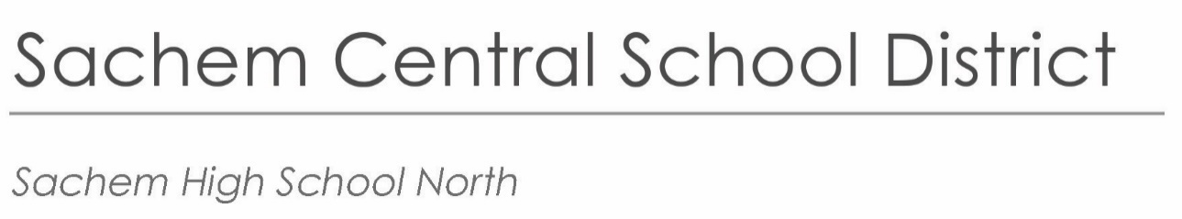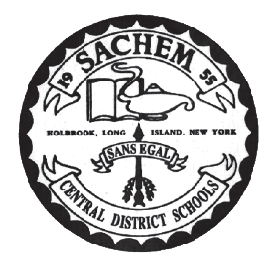

*Principal*  
Andrew Larson

alarson@sachem.edu

*Assistant Principals*  
Patrick Burke

John Galligan, Ed.D.

Brian Kolar

Lori Onesto

*Superintendent of Schools*  
Dr. Christopher Pellettieri

|  |
| --- |
| 212 Smith Road |
| Lake Ronkonkoma, NY 11779 |
| 631.471.1400 |
|  |
|  |

March 20, 2024

**RE: BOCES Closure**

Dear Parent/Guardian of BOCES Career Center Students:

This letter is to inform you that all BOCES Career Centers will be closed for the holiday of “Eid al Fitr” on Wednesday, April 10, 2024, and will therefore, be closed to all students. Sachem classes will be in session and all students are expected to attend.

**All** **students should take their regular transportation to school in the morning. All AM BOCES students must report to the auditorium for attendance and remain there until the start of their first scheduled class. All PM BOCES students should go to the auditorium after their last scheduled class. All ICC curb to curb students will be transported home after their classes end at Sachem.**

**Please be advised that Sachem also has a link for BOCES which can be viewed on the Sachem North website. You may visit this website for all the BOCES information throughout the school year.**

If you have any questions, please do not hesitate to contact my office at 631-471-1400 ext. 5520. Thank you in advance.

Sincerely,



Brian Kolar

Assistant Principal

BK/sd

www.sachem.edu